**Automation Execution Steps**

**Automated testing tools used:**

* SOAPUI(open source tool)
* Jenkins

**Scripting language:**

Groovy Scripting and Java

**Automation Flow:**

* All the test cases are scripted using groovy script and executed in Jenkins for CICD (Just a single click) even we can schedule the execution
* Here the RESTFUL API Service and SQLite data bases are connected using REST Service &JDBC drivers over script and perform the CRUD operations
* And all the data are retrieved using script and validated automatically
* Both business validation and technical validation are covered in automated testing
* After execution of testing ,the report will create automatically and if any record are deviated on assertion ,those records are captured in execution log

**Soapui download link:**

[**https://www.soapui.org/downloads/soapui/**](https://www.soapui.org/downloads/soapui/)

**Test Execution:**

**Step 1:**

**Place the Test automation project file under specified location**

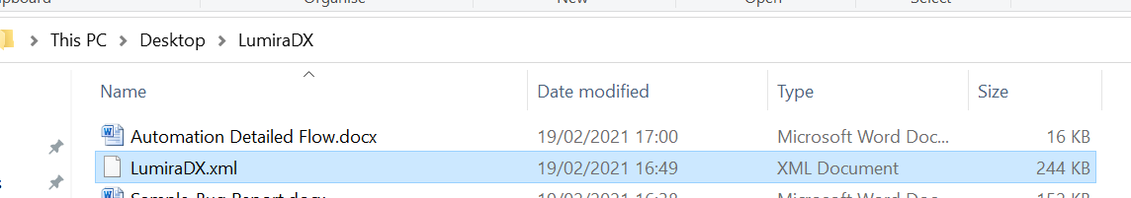

**Launching Soapui tool:**

**Step 2:**

**Route to this path in your machine and execute soapui.exe**

**C:\Program Files (x86)\SmartBear\SoapUI-5.5.0\bin**

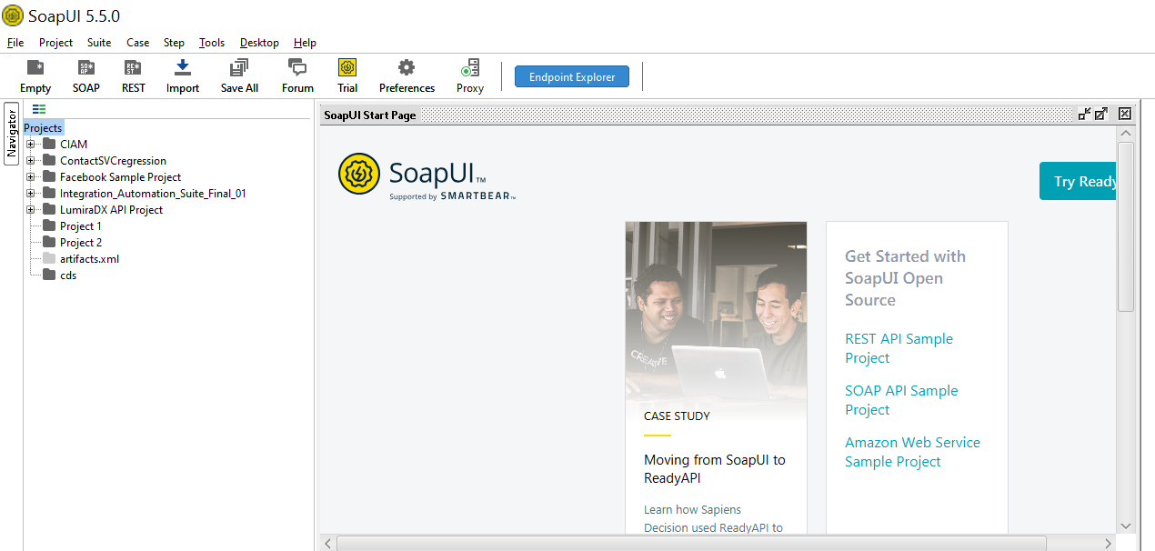

**Step 3:**

**Importing the automation Project:**

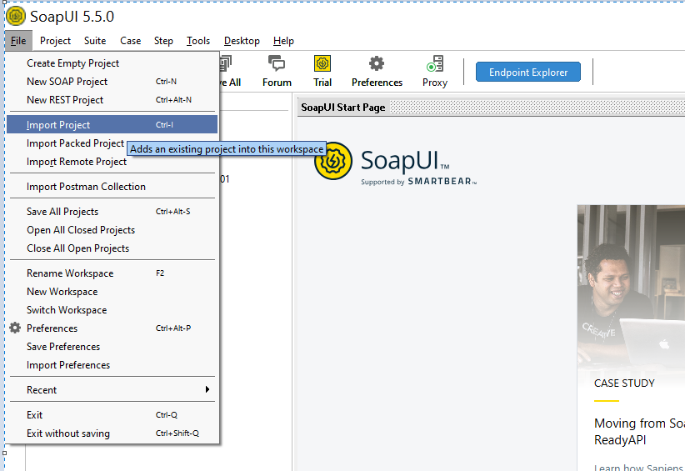

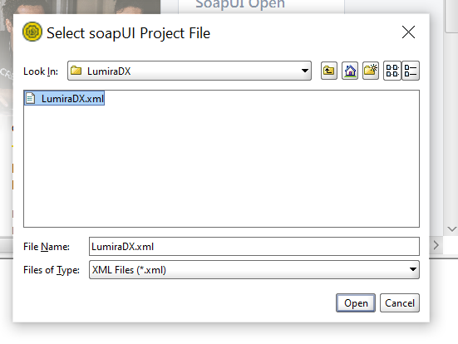

**Pre Request to execute automation:**

Launch the given demo API application in your machine

Update your machine path for report file name & folder path in automation framework

***Note: Click project and the custom property option***

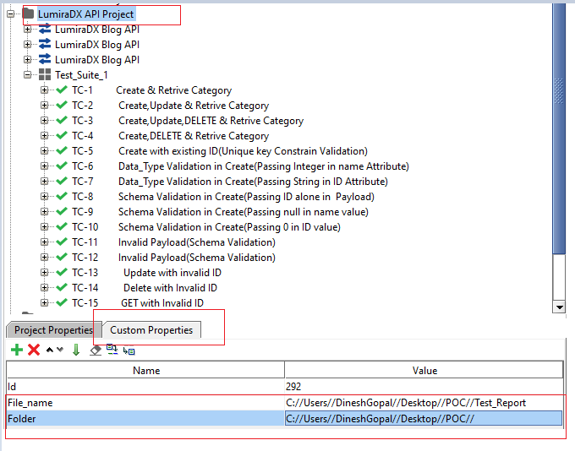

**Launch Jenkins:**

Create new project in Jenkins and update Build as Execute Windows batch command

With your soapui application path and automation file path

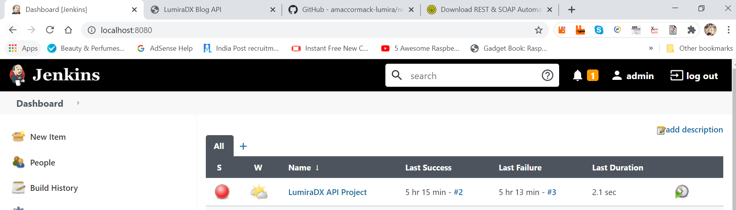

Under Configure option:

cd C:\Program Files (x86)\SmartBear\SoapUI-5.5.0\bin

testrunner.bat C:\Users\DineshGopal\Desktop\LumiraDX\LumiraDX.xml

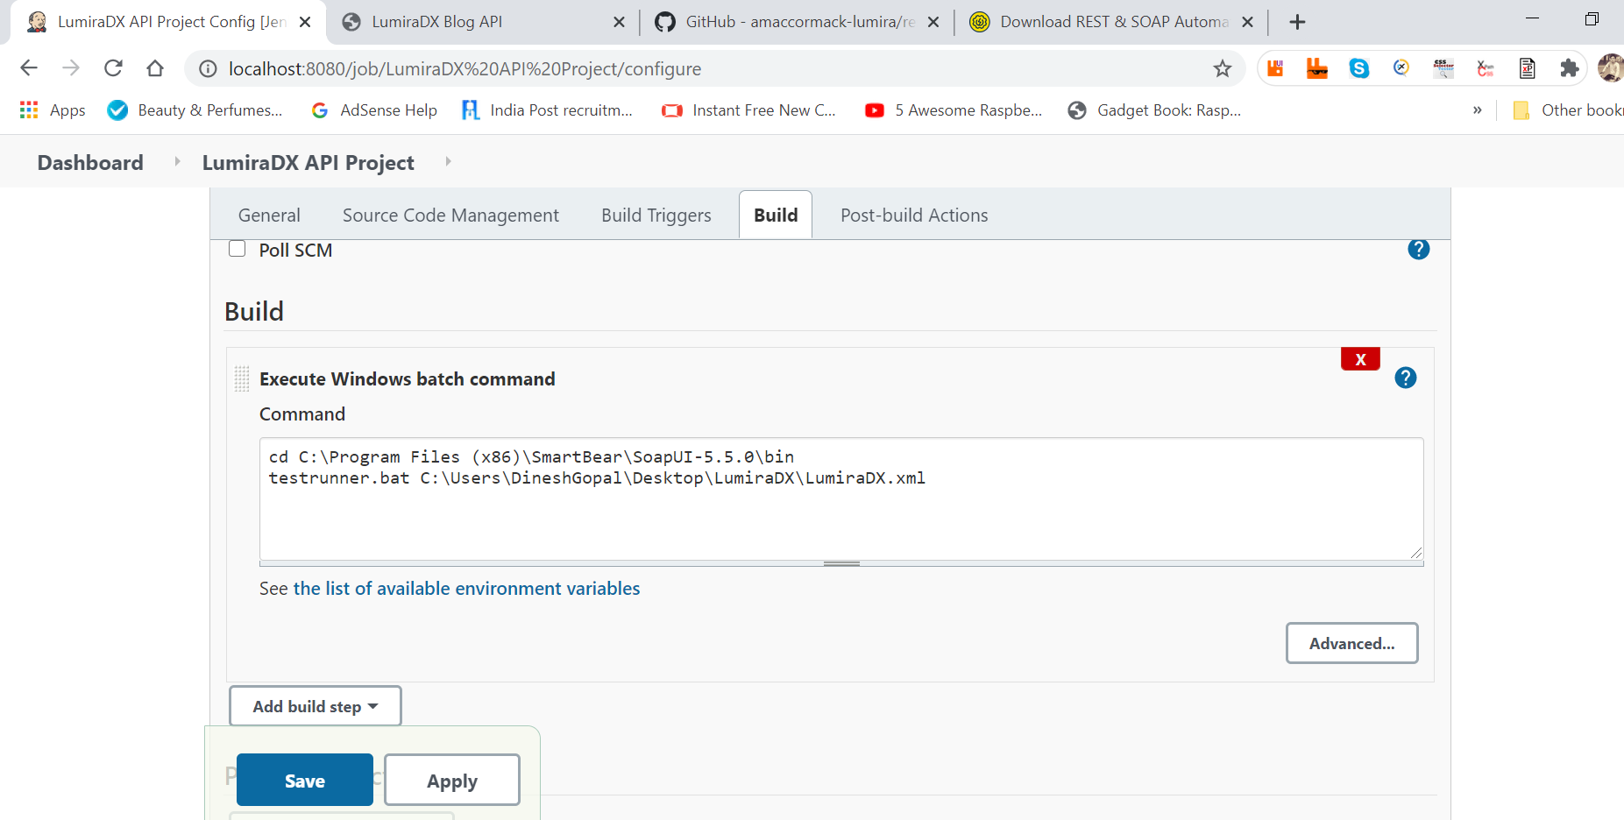

My report Folder path:

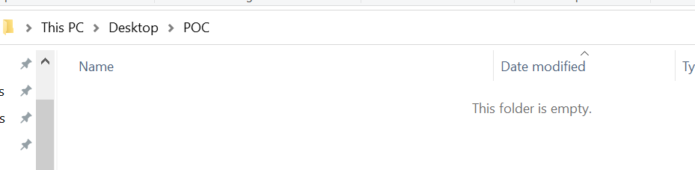

Execution of automated Script via Jenkins even we can auto schedule:

Click Build Now option

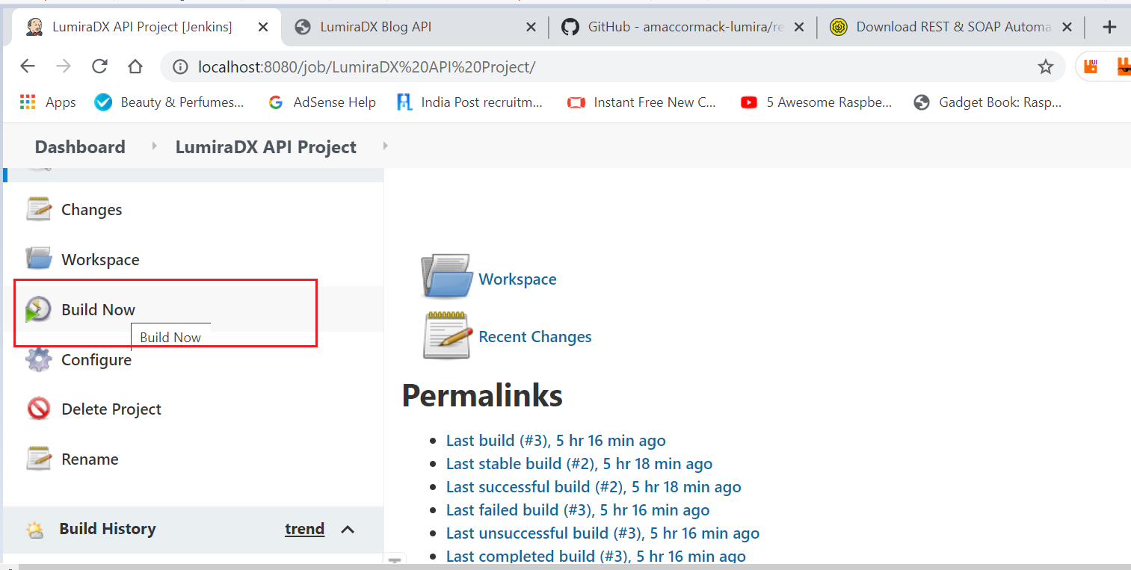

Under Build History:

Build Completed(test Execution Completed)

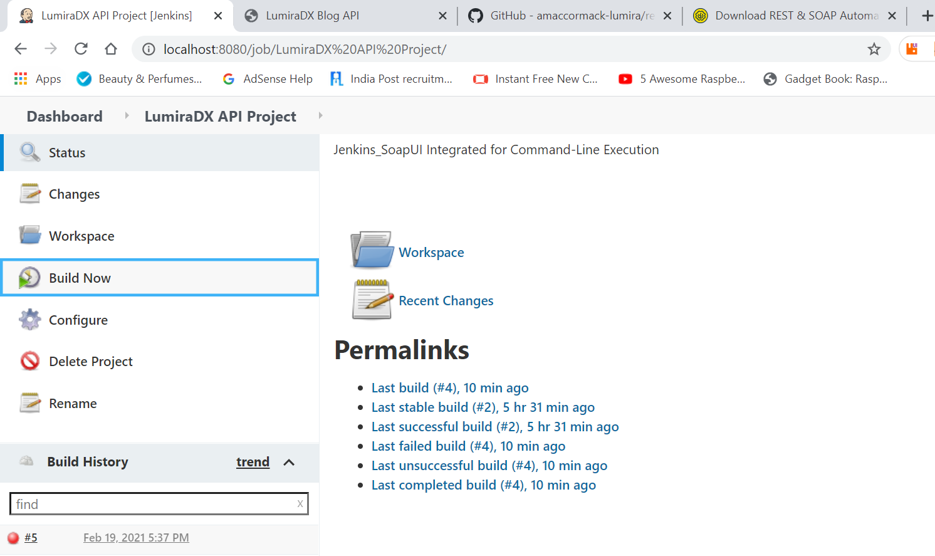

Console Output:

Click the completed build under Build History

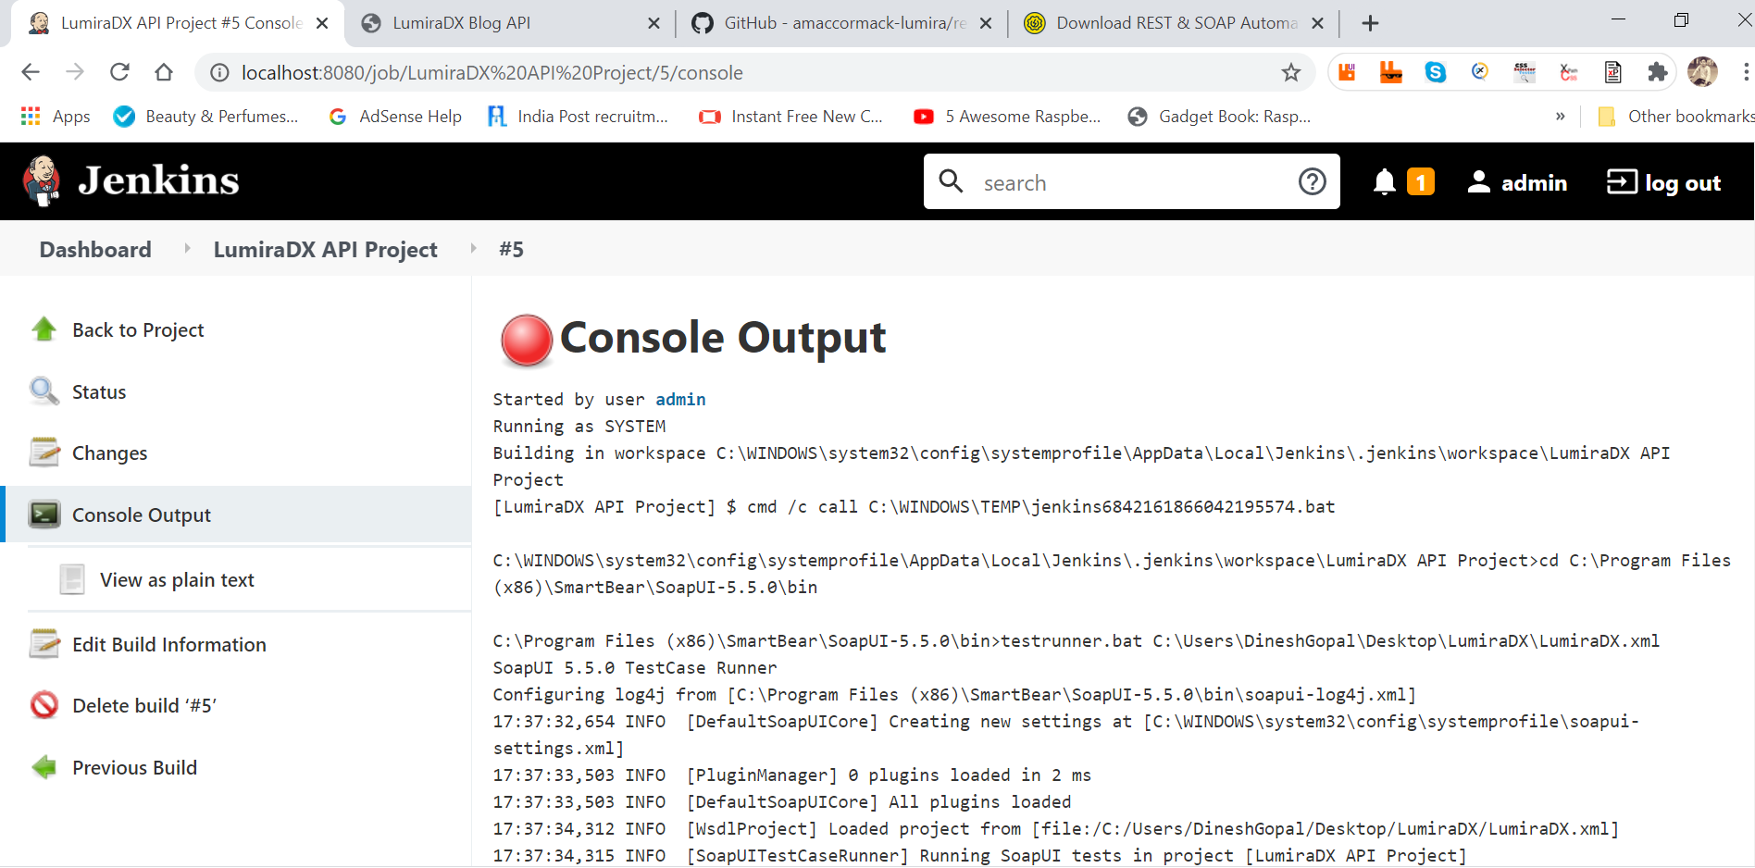

Report Folder after Execution:

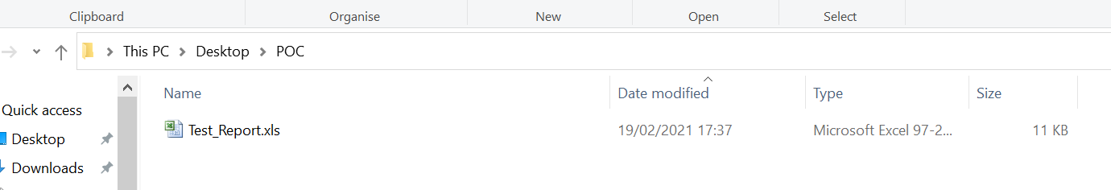

Auto Generated Test Report using Groovy Script:

